Read the whole document very carefully. These instructions are really crucial for a good grade.

**General Instructions**  
Course materials are divided into **4 volumes**. There will be 1 midterm, 1 final, 2 quizzes (best 1 will be counted), a semester project, and an in-class assignment (marks distribution given later).  
**Exam Syllabus:**   
**Quiz 1**: Volume 1, **Quiz 2**: Volume 3, **Midterm**: Volumes 1 & 2, **Final**: Volumes 3 & 4.

There are **24 classes** in a semester. Mark this class-wise timeline below. Don’t miss deadlines.

| **Class no.** |  | **When?** | **Where?** |
| --- | --- | --- | --- |
| 1 | Introduction |  |  |
| 2 |  |  |  |
| 3 |  |  |  |
| 4 | Project group members finalization | Before class | Online:   [submit here](https://docs.google.com/spreadsheets/d/1RVKJitD4SXKEtikszSR5BaHcbWxSxYFC3HgHNw0e6wQ/edit?usp=sharing) |
| 5 |  |  |  |
| 6 | Project GitHub link submission deadline. | Before class | Online (google  classroom) |
| 7 | Quiz 1 + Bonus viva | Class time | In class |
| 8 |  |  |  |
| 9 |  |  |  |
| 10 |  |  |  |
| 11 |  |  |  |
| 12 | Project update | Class time | In class |
| 13 | Midterm exam | Class time | In class |
| 14 |  |  |  |
| 15 |  |  |  |
| 16 |  |  |  |
| 17 |  |  |  |
| 18 |  |  |  |
| 19 |  |  |  |
| 20 | Quiz 2 + Bonus viva | Class time | In class |
| 21 |  |  |  |
| 22 |  |  |  |
| 23 | Project submission deadline for everyone     Presentation of Groups 1-5 | 1) Before class  2) Class time (printed report)   Class time | 1) Online (GitHub)  2) In class  In class |
| 24 | Presentation of Groups 6-10 | Class time | In class |

**Marks distributions (out of 100%)**

| Attendance (RDS) | 7% |  | |
| --- | --- | --- | --- |
| Assignments (in-class) | 8% |
| Quiz (best 1 - out of 2) | 15% |
| Semester project | 15% | Project update - 3%  (on the 12th class) | a) Timeliness & Following instructions - 1% b) Quality of report, presentation, & GitHub - 1% c) Overall update quality - 1% |
| Final submission - 12%  (on the 23rd and 24th class) | a) Timeliness & Following instructions - 2%  b) Final report - 3% c) Presentation - 2.5% d) Code & GitHub - 2.5% e) Overall project - 2% |
| Midterm exam | 25% |  | |
| Final exam | 30% |

*Additionally, there will be an optional bonus viva worth 5% extra marks. It will be held on any quiz date of your choice, covering the syllabus of that quiz.*

This course will follow the grading policy of NSU ([see here](https://www.northsouth.edu/academic/grading-policy.html)).

**Attendance marks assessment policy**

See this table for the attendance marks assessment policy:

| **Attendance** | Below 40 % | 40 - 49% | 50 - 59% | 60 - 69 % | 70 - 79 % | 80 - 100 % | 90 % + |
| --- | --- | --- | --- | --- | --- | --- | --- |
| **Marks** | 0 | 1 | 2 | 3 | 4 | 5 |  |

These attendance percentage values will be taken directly from the RDS portal. Please be very careful about ID card punches. Any issues with ID cards must be fixed before class.

*Special note: Please note from the table above that the attendance requirement ranges have been relaxed from what should be the ideal. For example, note that* ***80% attendance*** *will earn you full marks, even though this threshold should* ***ideally be 90%****. This grace accounts for unforeseen situations like arriving late due to heavy traffic, illness, late enrollment in the course, ID card punching issues, and similar cases. Since this grace is already applied to everyone, there’s no need to approach me individually about attendance adjustments for these reasons.*

**Assignments:** I will explain this in class.

**Semester Project Instructions** (10 groups total - 10 projects)

I will try to assess how much effort you put into each task.

**Project Update (on the 12th class)**,

You have to submit the following files. Make sure not to miss the deadline.

| **What to submit ?** |  | **Where to submit ?** | **When is the deadline ?** |
| --- | --- | --- | --- |
| 1) Update presentation file |  | GitHub | Before the start of the 12th class. |
| 2) Two-page update report  *no top page, no spiral binding* | Digital soft copy | GitHub | Before the start of the 12th class. |
| Printed hard copy (both-sided print) | Bring in the class | At the very start of the 12th class. |
| 3) The codes |  | GitHub | Before the start of the 12th class. |

*Groups 1 to 10 will present sequentially in 5-minute slots between the 10th and 60th minutes of the class (see Fig. 1). Special note: If your previous group is not finished in time, you must intervene and start your presentation, when your time slot starts. If you do not do it, you will be giving up times from your own 5 minute time slot, which cannot be recovered later.*It is very important to note that it’s your responsibility to start & end your presentation on time. I will not ask any group to stop or start. You will have to automatically start it & end it, when your time comes. It’s very important as I will note this discipline & this can greatly impact your marks.You will present using only the files (pptx file, video file, codes, etc.) you submitted to your GitHub repository before the deadline. Laptops are not allowed during the presentation.   
**Important:** Please ensure all 10 groups submit their printed hard-copy update reports at the very start of the 12th class. Submitting on time is crucial, as late submissions will unfortunately affect your report marks.

**Final Project Submission (on the 23rd and 24th class)**,

You have to submit the following files. The deadlines in this table are applicable for **all 10 groups**. Make sure not to miss the deadline.

| **What to submit ?** |  | **Where to submit ?** | **Deadline ? (for all 10 groups)** |
| --- | --- | --- | --- |
| 1) Final presentation file |  | GitHub | Before the start of the 23rd class. |
| 2) Eight-page final report  *no top page, no spiral binding* | Digital soft copy | GitHub | Before the start of the 23rd class. |
| Printed hard copy (both-sided print) | Bring in the class | At the very start of the 23rd class. |
| 3) The codes |  | GitHub | Before the start of the 23rd class. |
| 4) One-minute video demo | Project demo run | GitHub | Before the start of the 23rd class. |

*Groups 1 to 5 will present sequentially in the 23rd class, and groups 6 to 10 will sequentially present in the 24th class. Presentations will follow sequential 15-minute slots between the 15th and 90th minutes of each class (see Fig. 1).* **Everyone must be present in both the 23rd and 24th classes.** *Special note: If your previous group is not finished in time, you must intervene and start your presentation, when your time slot starts. If you do not do it, you will be giving up times from your own 15 minute time slot, which cannot be recovered later.*It is very important to note that it’s your responsibility to start & end your presentation on time. I will not ask any group to stop or start. You will have to automatically start it & end it, when your time comes. It’s very important as I will note this discipline & this can greatly impact your marks.You will present using only the files (pptx file, video file, codes, etc.) you submitted to your GitHub repository before the deadline. Laptops are not allowed during the presentation.   
**Important:** Please ensure all 10 groups submit their printed hard-copy final reports at the very start of the 23rd class. Submitting on time is crucial, as late submissions will unfortunately affect your report marks.

Penalties will apply for absences, late submissions, insufficient GitHub activity, any form of cheating, lacking in working as a team, etc. Bonus: for asking questions in the final presentation.

**Project report (both final report & update report)**

The reports have to be very very well written, it’s really important. It can have a significant impact on your project marks. Follow a professional article format (such as, IEEE double-column). Make it very professional; write-ups, figures, equations, everything. For guidance, you can browse through the scientific articles in Google Scholar or any renowned scientific publishers such as Nature, Science, IEEE, Wiley, etc. A well-written report usually takes a lot of time and effort to write. A good idea would be to go through available online resources teaching scientific writing; you will need this throughout your career if your plan is to pursue academia/research/PhD, etc. in the long run. Cite all references you used in your project (including videos and AI tools, if any). Finally, be very careful to avoid plagiarism. Page length: 2-page for the update report, 8-page for the final report.

There must not be a top page for any report. Instead, above the top margin of the first page, include the following as a header: 1) course code & section, 2) project group no., 3) names and IDs of all group members. Also, print them both-sided, and avoid spiral binding and thick pages.

**Presentation (both final & update)**

The presentation will also have to be entertaining and informative. Avoid unnecessary introductions and go directly to the main part. You can have introductions, significance, conclusions, future work, etc., in your presentation, but they must be very short and to the point. You will also need to do good homework for proper time management. Any writings must be visible clearly. You need two different strategies when you are presenting the PPTX file vs the codes from GitHub. For example, when you are presenting the PPTX file, you should focus more on the big picture. Whereas, when you are presenting the code, you might need to use more technical language. You will get good grades in presentation for 1) speaking to the point, 2) clear explanation, 3) quality of slides, 4) generating curiosity in the audience, 5) contents specific to your work and experience. Your presentation marks will be affected for 1) unnecessary slides, 2) taking unnecessary times, 3) finishing late or too early, 4) too much text, 5) very general, vague ‘fits-for-all’ slides.

Focus on the main goal of the project and your main approach to solve the problem. You will have to present the codes directly from GitHub using the computer in the classroom. You cannot run the code while you are presenting, instead create a one minute video showing the code run. While presenting the code, you must show the 1) GitHub repo home page with a well-written README.md file, 2) A quick scroll over the GitHub commit history, 3) Every part of the code from GitHub, 4) Every part of the GitHub repo. Note that I want to see good teamwork and continuously working on the project throughout the semester. Your GitHub commit history must reflect that.

Make sure to go through every part of the code & the GitHub repo within the 4-minute time frame (see Fig. 1). The one-minute video demo (see Fig. 1) will showcase your project's functionality from the user's perspective, recorded through screen capture.

Each page of your presentation file must have a footer containing the following information: 1) Group number 2) Names of all group members. It is mandatory. Finally, you must start any presentation in this course by introducing all group members and stating their full names.

**Project GitHub repository**

Each group must create a single public GitHub repository for their project and submit it by the deadline. All project files, except large data files, must be added here once they are created.

Your GitHub repository must be organized exactly like this:   
1) Contains a main code file named main (e.g., main.py, main.c, main.java, etc.) to run your project.   
2) Contains a README.md file to explain your project.   
3) Contains a requirements.txt file to list the tools or libraries your project needs.   
4) Has a subfolder named data containing any datasets.  
5) Has a subfolder named support containing other code files.   
6) Has a subfolder named others, containing a) the final presentation PPTX file, b) the final report PDF, c) the update presentation PPTX file, d) the update report PDF, e) the one-minute video file showing the project demo run.

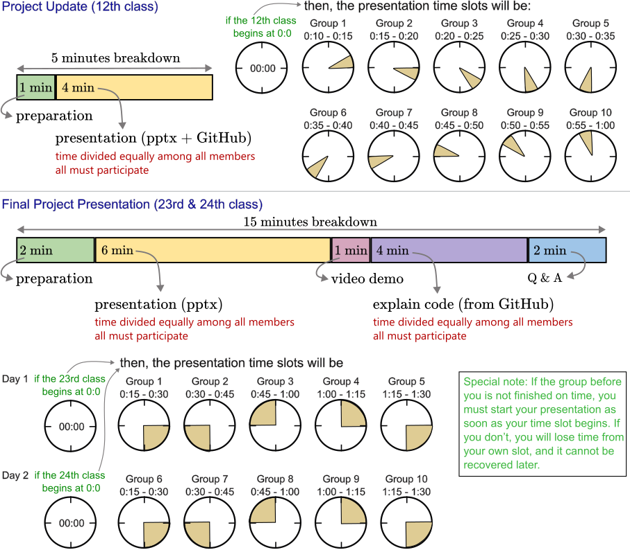  
**Figure 1**: Time slots and timing breakdowns for the project update and final project presentation. Please note that there are marks for time management and following instructions.

**Exam policy**

Quiz 1 and 2 will be in MCQ format. There will be 15 questions in total. You will need to fill out the circles in the OMR answer sheet (embedded with the question paper) with ballpoint pens. Total time: 20 minutes.

Midterm will have 5 written questions (5 marks each). Total time: 50 minutes.

Final exam will have 6 written questions (5 marks each). Total time: 1 hour.

Questions may have subparts. You will need to answer all questions, no options will be given.

In the midterm and final, the questions will be embedded in the answer sheet and you will be given a set amount of space after each question to write your answer. You must complete your answer within that space. There will be a page for Rough calculations and brainstorming. Do not write answers in the Rough page.

Name & ID: Please write your complete name and ID exactly as the one provided in RDS.

**Make-up exam policy**

A make-up exam cannot be taken if you have already taken the original exam. A make-up exam may only be considered if you are unable to attend an exam or a test due to a major medical emergency. In this case, you must provide

1) A doctor's prescription with the date, and

2) A medical certificate signed and attested by a doctor specifically confirming that you were unwell and unable to take the exam on the day of the test.  
   
Additionally, these documents will need to be verified and double-checked externally. Any attempts to provide fabricated or false documents will have serious consequences.  
Important: You must request for a make-up exam before the exam takes place.

Finally, try your best to avoid make-up exams. The difficulty level in make-up exam questions is usually higher than that of the original exam.

**Caution**

Be very careful of the following, as they might cause serious consequences, from badly hurting your grade up to the cancellation of the exam/test/assignment:

1) Missing a deadline, 2) Late arrival on exam and project presentation days, 2) Found guilty of any unethical practices in exams, projects, assignments.

**Contacts**

email: [rabbi.mohammad@northsouth.edu](mailto:rabbi.mohammad@northsouth.edu), phone: 01716375274, Office: SAC 1146.  
Office hours: see google classroom  
Initial: MSRb